2018 Mohegan Strider Youth Road Race Circuit
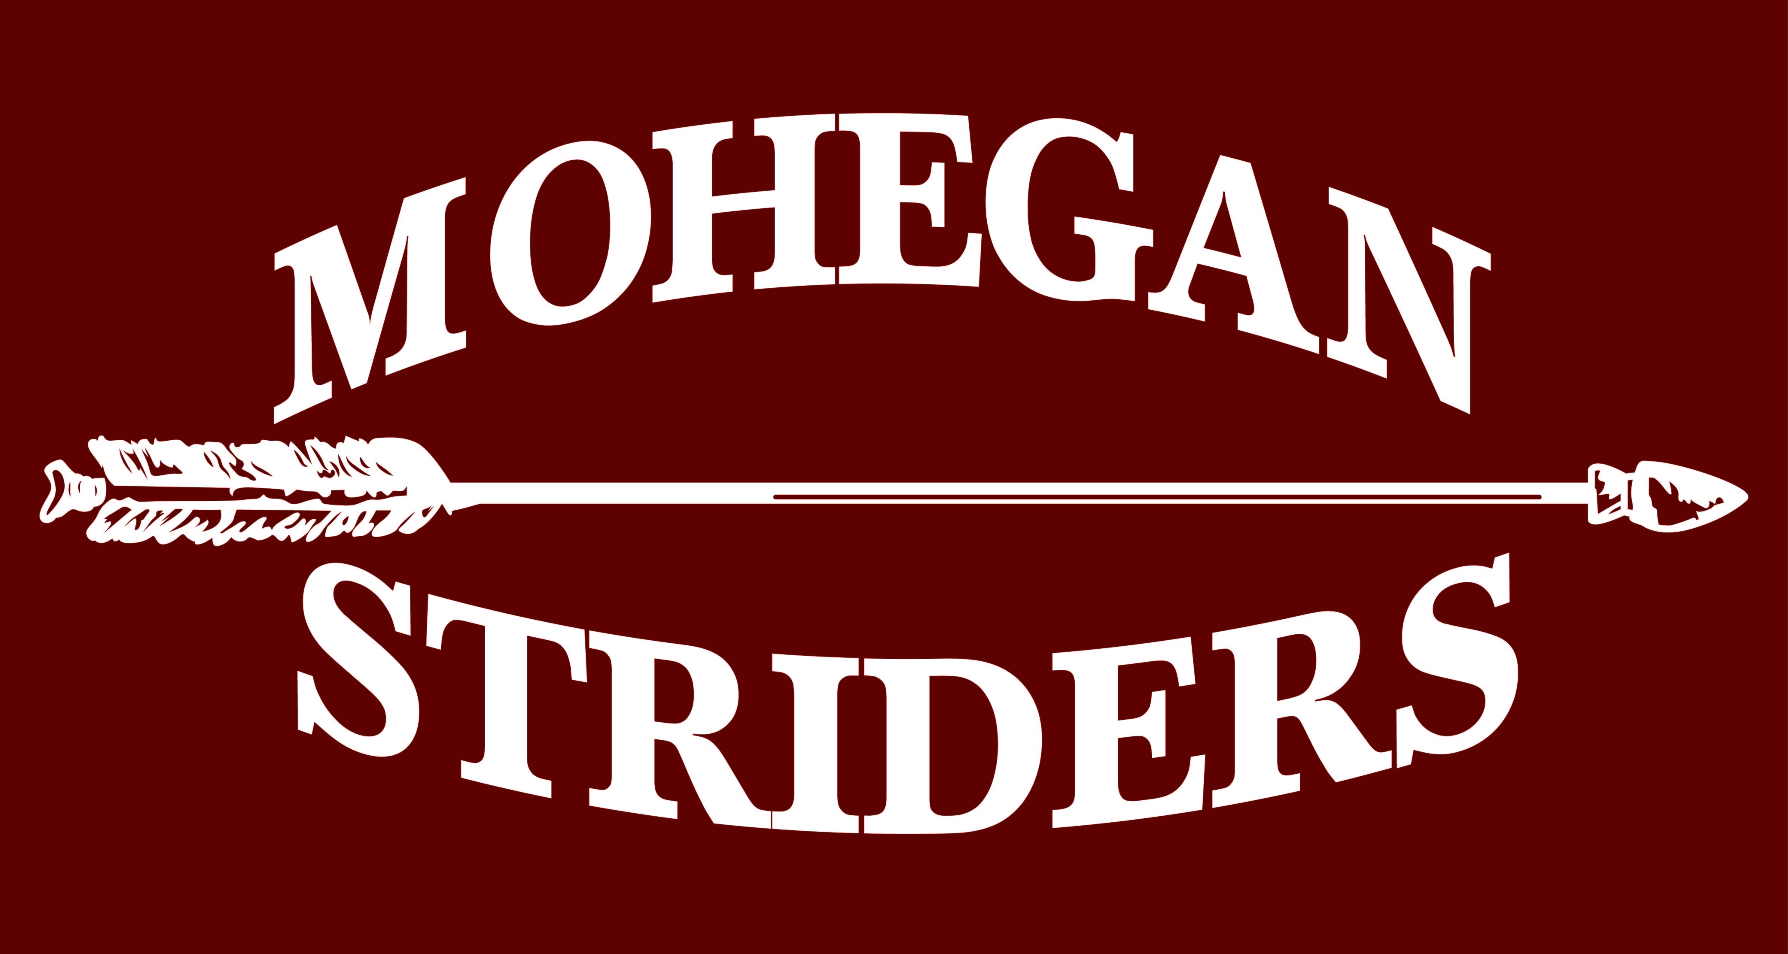

3/31 St Joseph Road Race, Baltic
4/28 Joe Kelly Road Race, Lisbon
5/26 – Runners in Support of Education, N. Stonington
6/24 – Cannonball Run, Preston
7/21 – Greenville Mile, Norwich
8/15 – Nick Bottone Mile, Westerly, RI
9/29 – Sacred Heart Dash, Norwich
Every Monday, 7/9 – 8/27 - Franklin Rec Runs 6:00pm
Every Thursday, 7/12 – 8/30 – Norwich Rec Runs 6:00pm

Mohegan Strider Youth Road Race Circuit Program Details

- All Mohegan Strider Youth Members, ages 13 and under, are eligible to score
- Teen Striders should check out the Under-18 division of the Adult Grand Prix circuit at www.moheganstriders.com
- 10 points for each race participated in, regardless of finish
- 5 points for each rec run attended (Norwich and Franklin)
- Top 3 point scorers (M/F) receive awards at the Mohegan Strider Banquet in January, 2019.
- Entry fees vary by event - click on the race name for a link to the entry form; Most races offer T-shirts and ribbons to all finishers
- Franklin and Norwich Rec Runs are FREE. Click HERE to register for the Norwich Rec Run. No registration required for Franklin.
- Help ensure your participation is recorded by signing in on the team clipboard at each event!
- Want a Mohegan Strider Uniform? Contact me and I can provide one for you. Cost is $25, payable to Mohegan Striders.
- For more information, Contact Chad Johnson at runninboy@comcast.net or 860-617-1144

